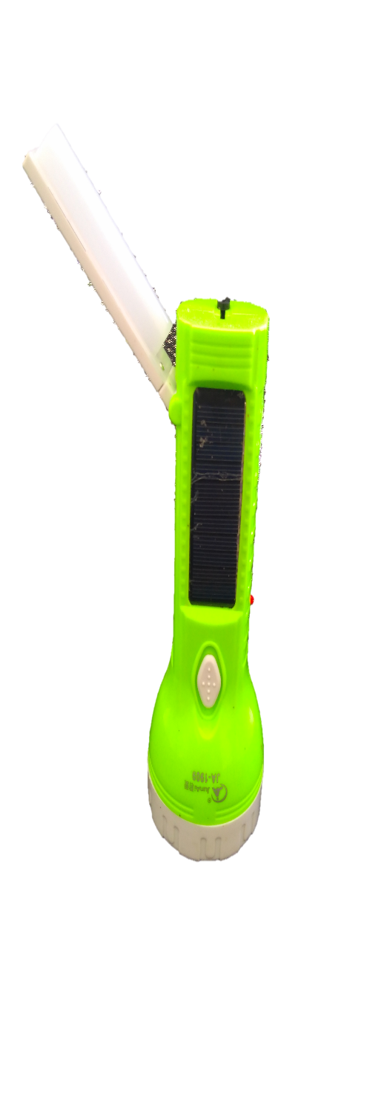 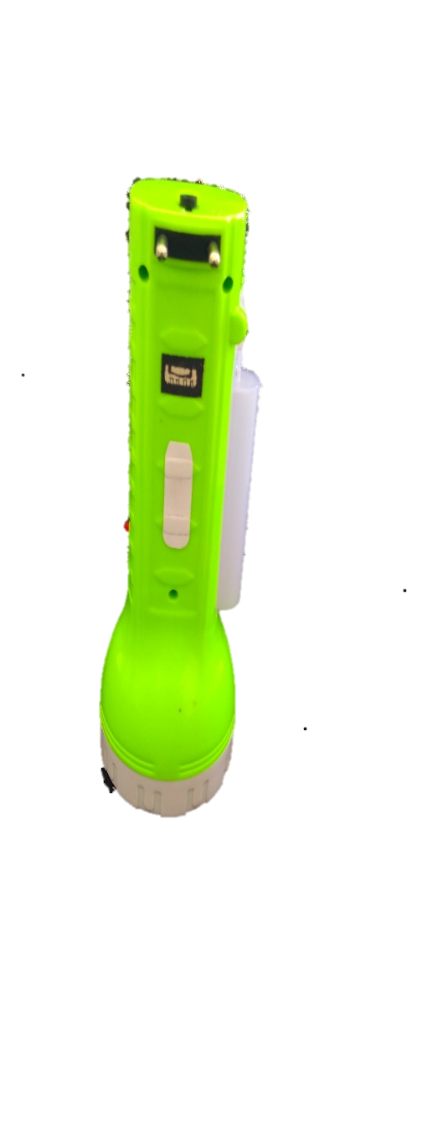

Big moveable light

Outlet mover

Charge electrical outlet

Distance maintaining button

Charging Indicator

On/Off Button

Solar Panel

180

Charging Adaptor

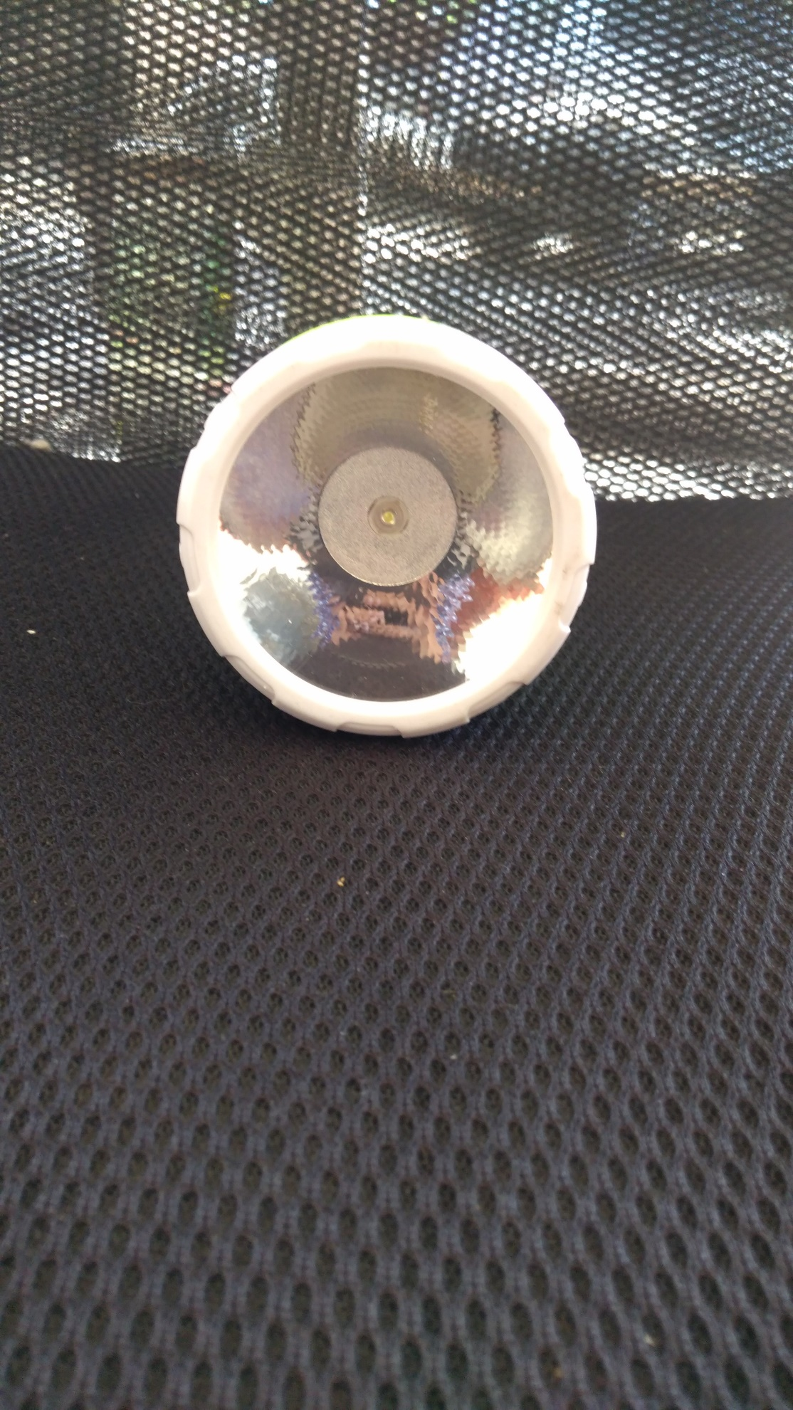

Front torch with 9 LED lights

**Thank you:**

Thank you for being our valued customers. We are grateful for the pleasure of serving you and meeting your needs. JUNAI Series Flashlight with novel design and high quality will provide you with good convenience for your life, work, study and travel. We value your patronage and appreciate your confidence in us. Counting you among our customers is something for which we are especially grateful.

**Features of product:**

1. With long life non-maintenance battery, above 200 times circulating using.
2. Most powerful battery that can save up to 1000 voltages.
3. Using charging adaptor user can charge their mobile phone and other compatible devices.
4. With super bright, long life and electrically saving LED.
5. Adopt special focus reflecting cap, the light can reach as far as 150 meters.
6. By the distance managing button you can set distance up to which light is required this will increase the quality of light.

**Charging Methods**

1. Push the plug out when lights charging and insert it directly into 110V-250v socket.
2. The charging indicator light on.
3. Full charging requires is 8-15 hours.
4. This product can also be charged by solar power.
5. Full charging requires 15-20 hours.
6. The light can last more than 8 hours with full power.

**Usage Instructions**

1. Push the switch button to the front, led lights or 1 led will be on.
2. Push the switch button to the back, 10 SMD light will be on.
3. Push to the middle, the lights will be off.
4. Press the back point of distance maintaining button to decrease the distance of light.
5. Press the front point of distance maintaining button to increase the distance of light.
6. Repeat successively like this.

**Cautions**

1. When the energy power is exhausted, please charge it immediately.
2. The product should be used and charged frequently, and when you do not use it for a long time, please charge it up every two months, otherwise, the service life of this product will be reduced.
3. The at most charge time should be less than24 hours.
4. Don’t use it when charging.
5. Don’t let it be wet or caught in rain.

**Quality Guarantee**

This product is guaranteed for three months from the purchase if any real quality problems occur. However, if damaged caused by user’s incorrect usage then operations are not included.